Full Name: Archana Govindan

Employee ID: 20170720

Wipro Email-ID: archana.govindan@wipro.com

Project Name (You are billing / or Bench) : IES-CTO_INVEST (non billable)

Competency Group: iDEAS-ER&D

1. Listing image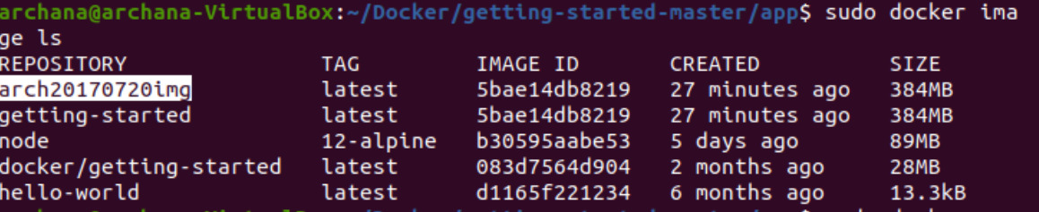
2. Listing containers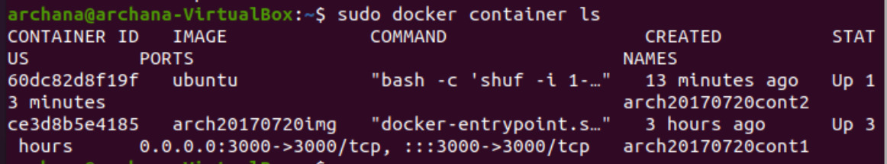
3. Results on web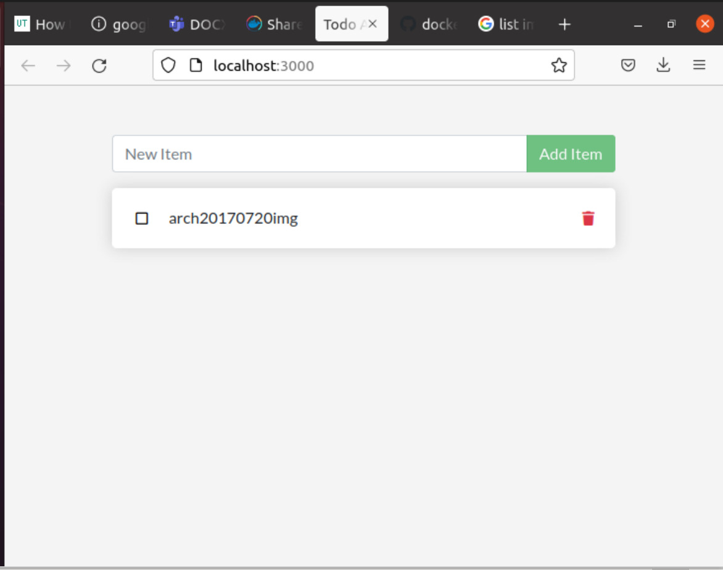
4. Result after updating and sharing.

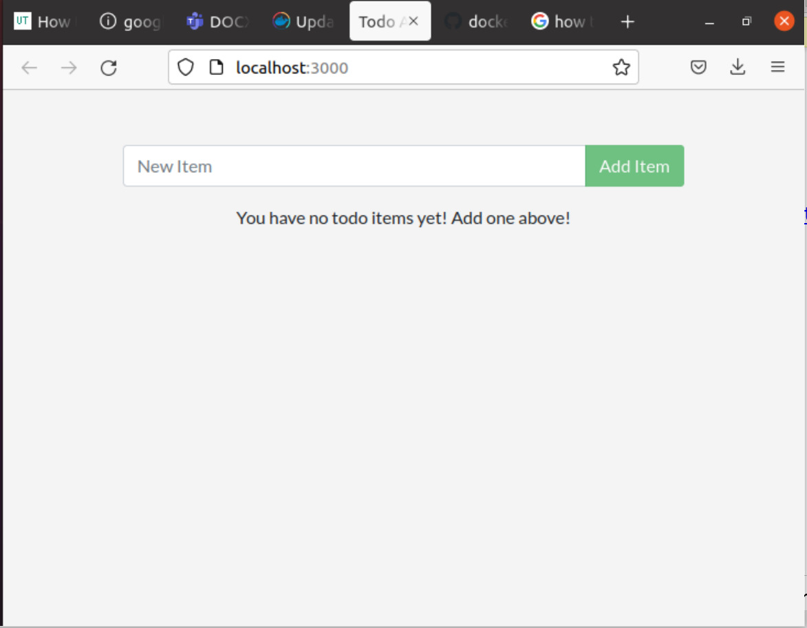

1. Result after persisting the database using volumes

